Registartion  
No popup message after the registration!  
Unable to register the new accounts

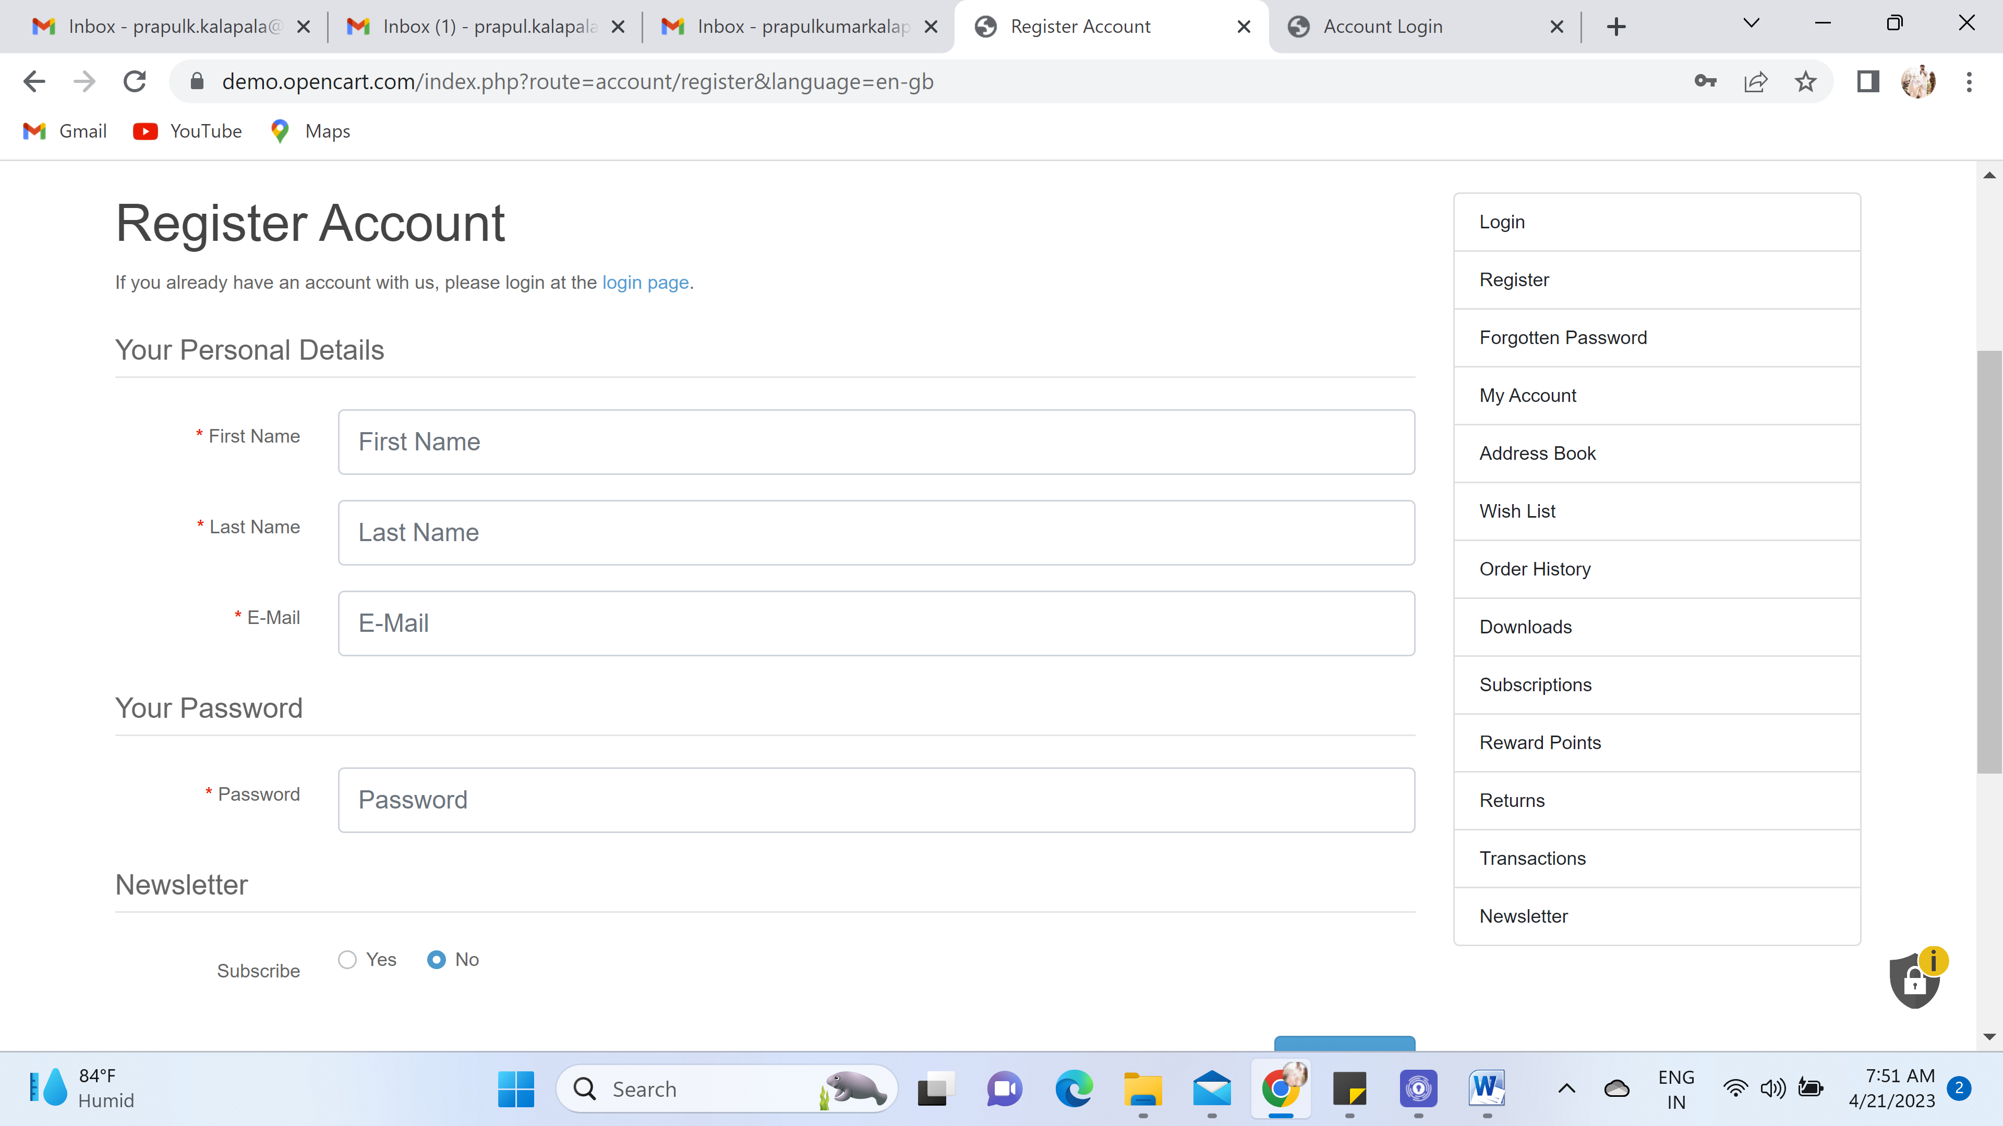

2. Picked the item and added to the cart, Message received

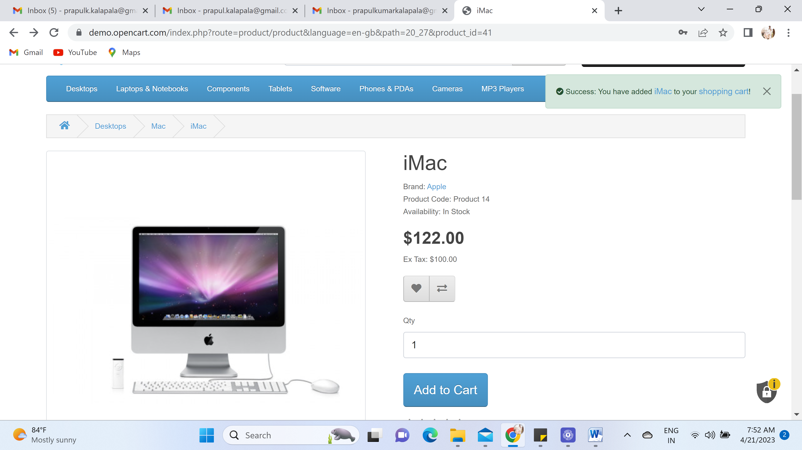

3. Shopping cart empty after adding the item to the cart!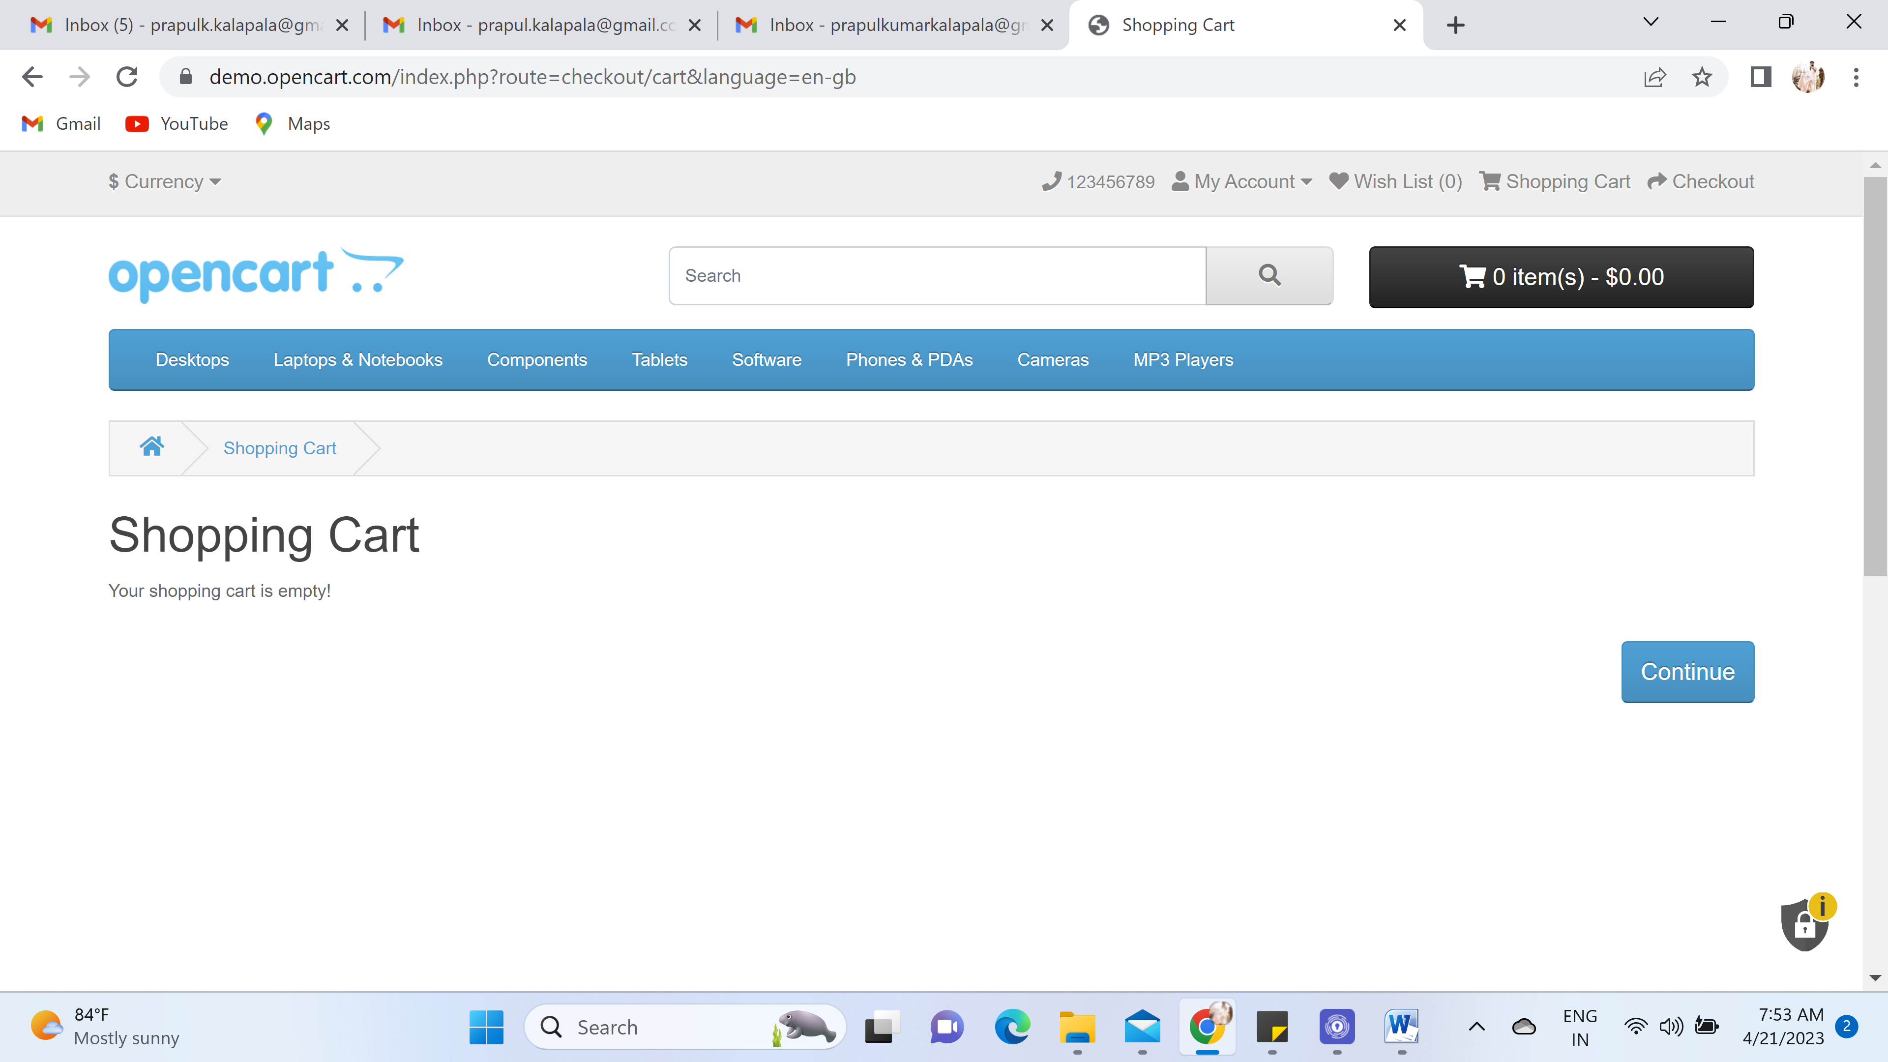

4. pictures were added wrongly in monitor section they added camera in the item pics list.  
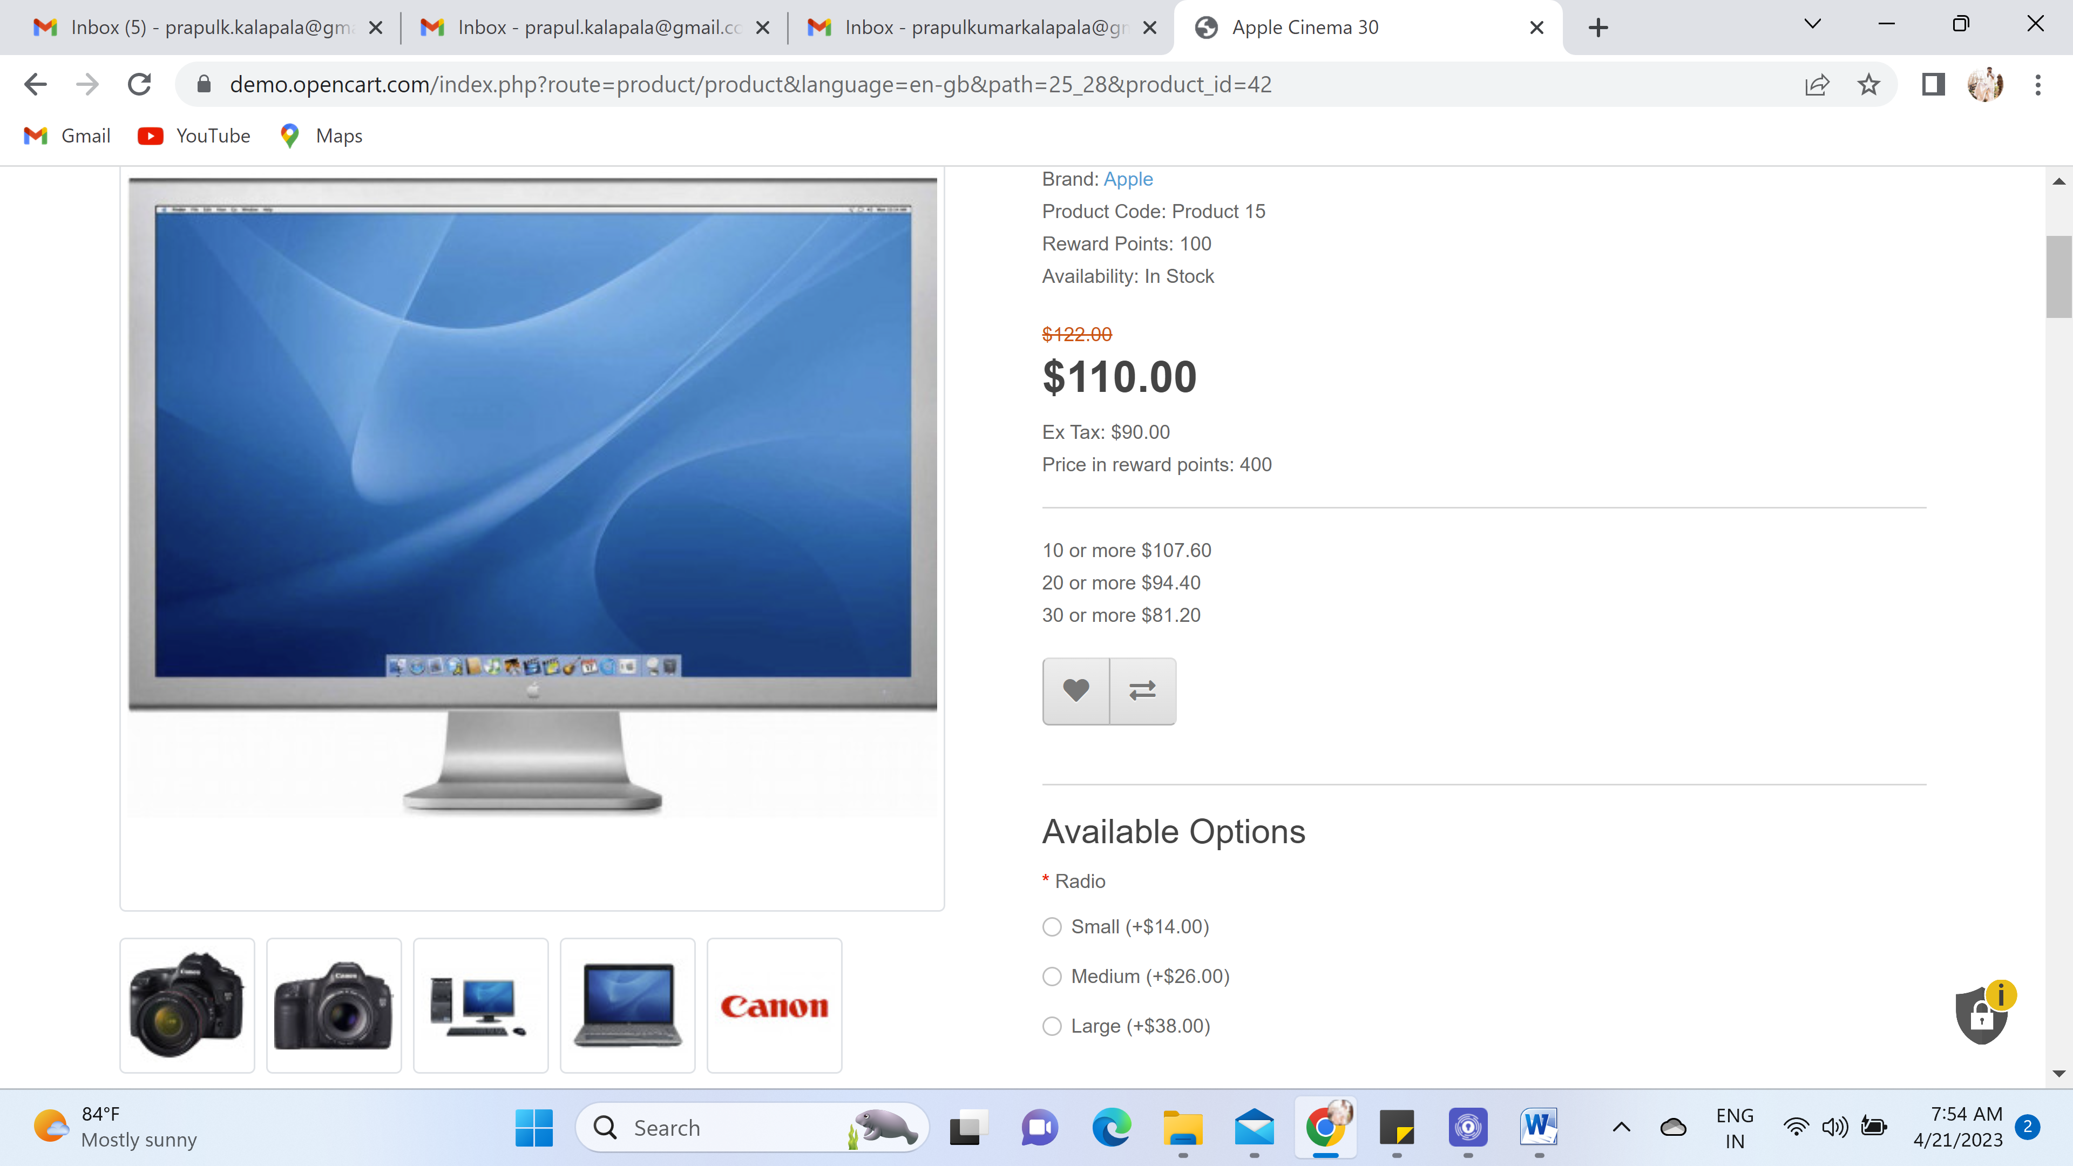

5. In camera section dropdown list is not mentioned, unable to add to the cart without selecting that field.

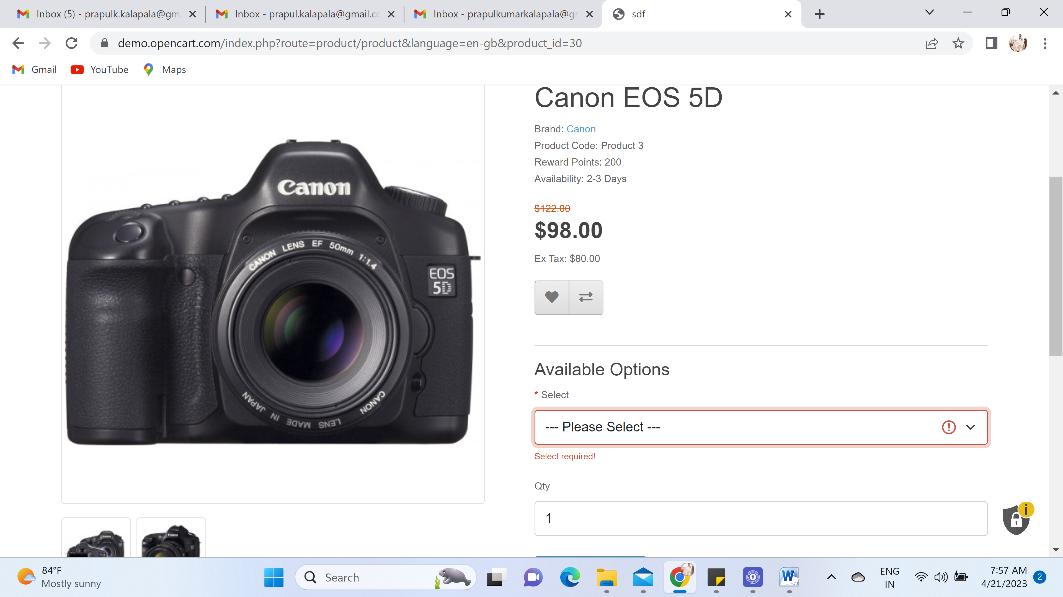

6. In Bottom Information section, none of the field doesn’t have any data In Term & Conditions, Delivery Information, About Us and Privacy Polciy.

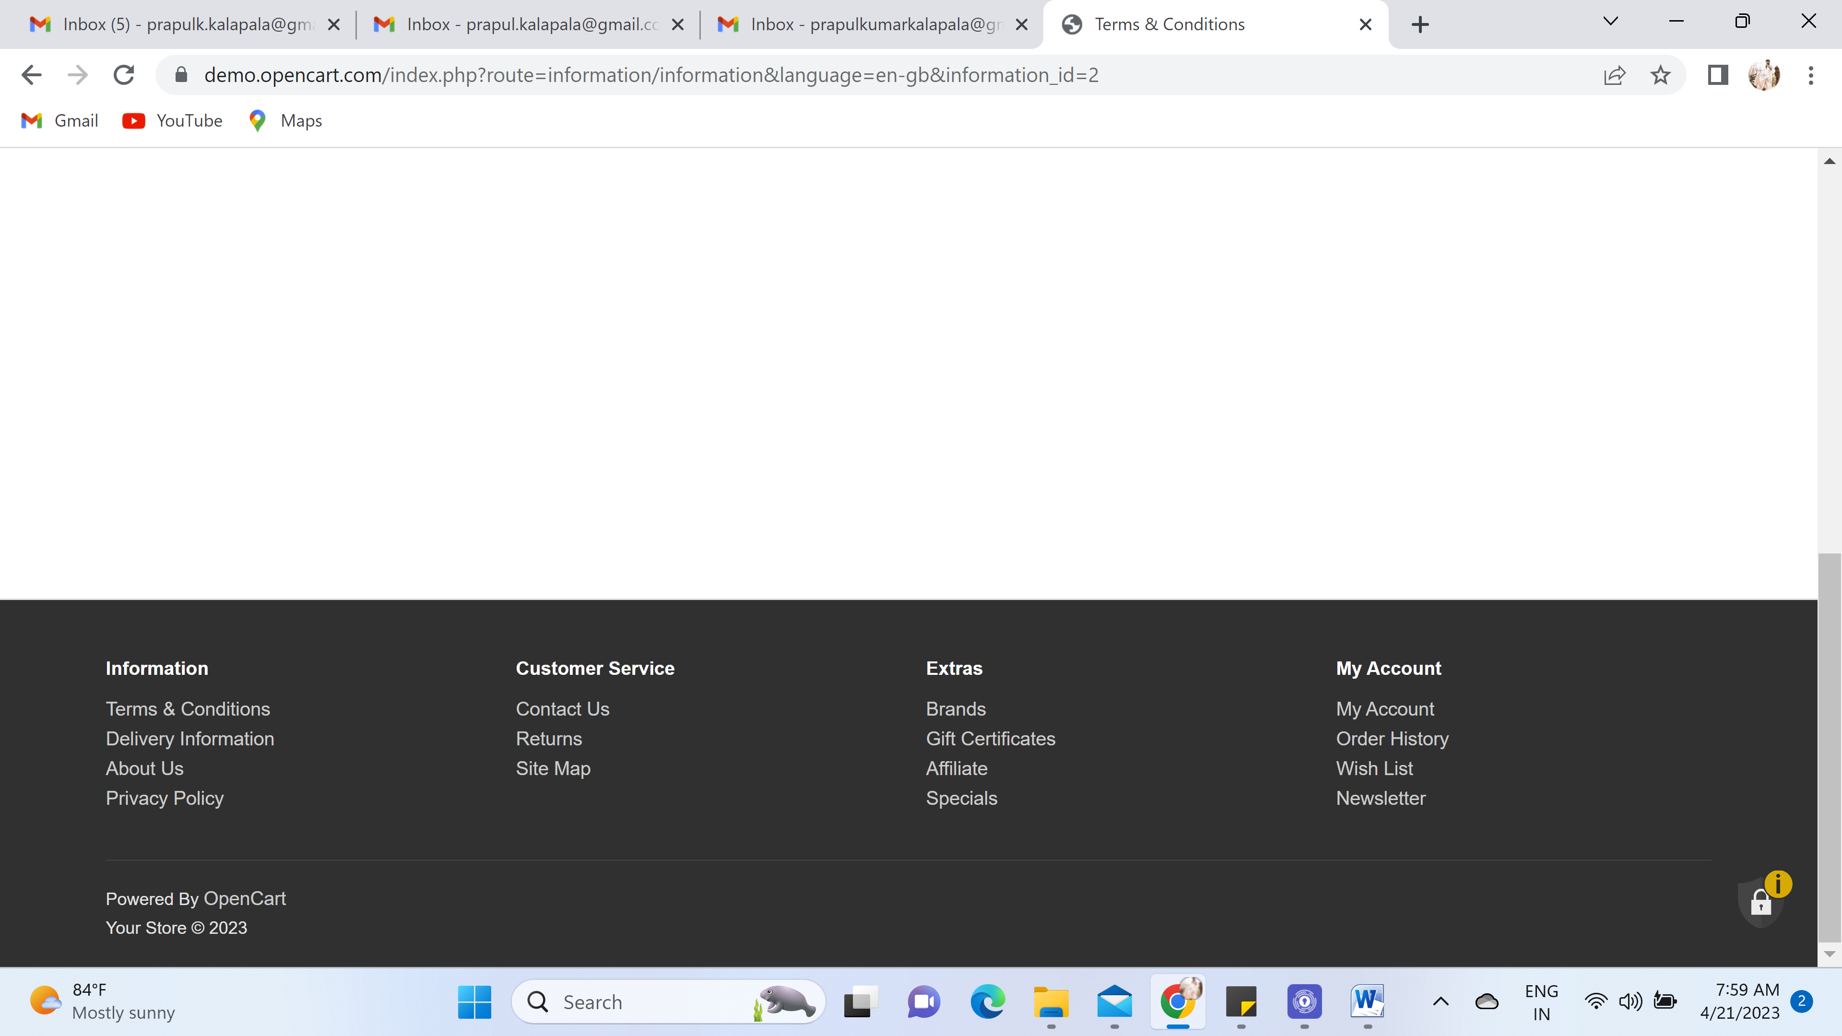

7. Contact Us section is working in Customer service but it is not showing the wrong email I gave [kumar@1234.com](mailto:kumar@1234.com) and it is working  
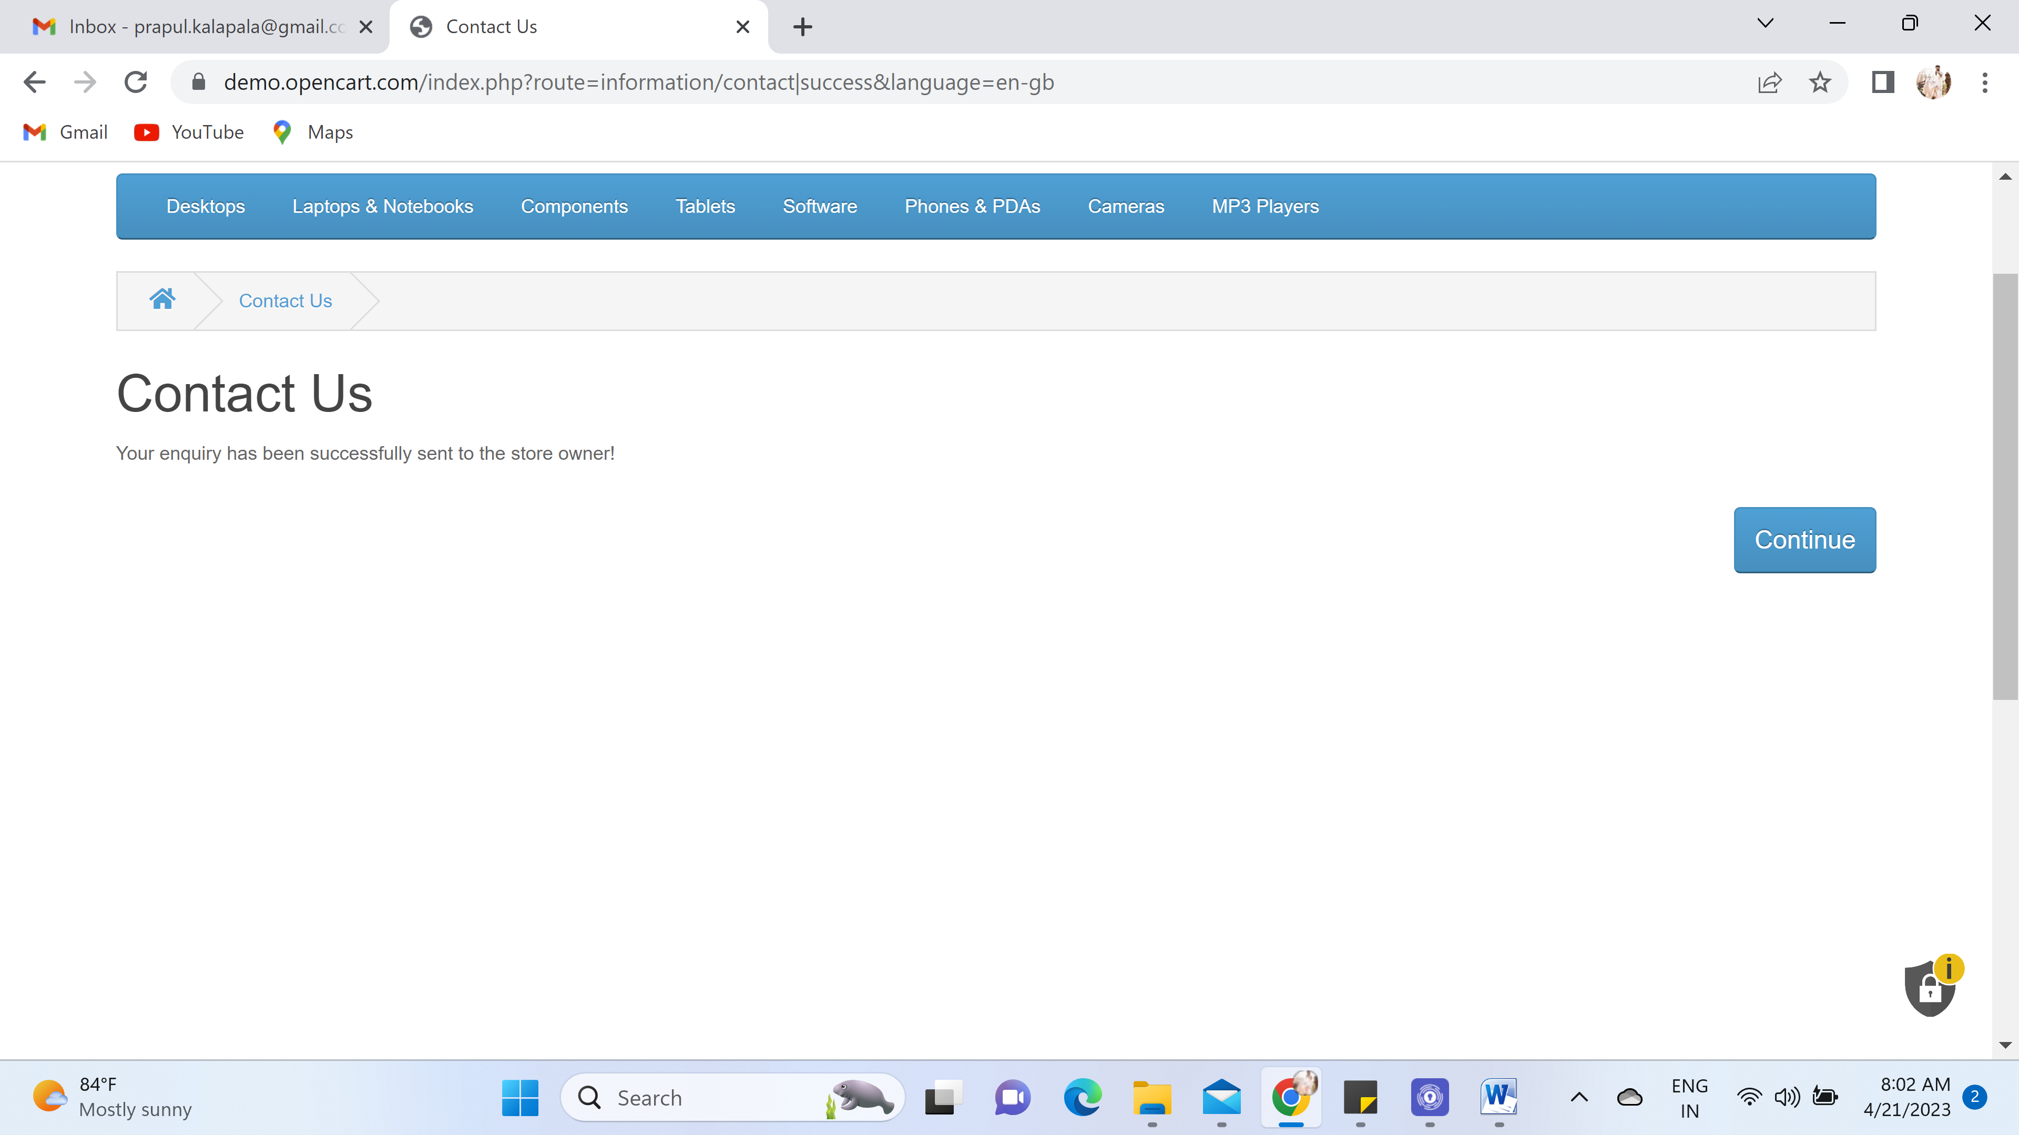

8. Returns, After filling all the details of the page the page is not giving any message or update of the return of my order.

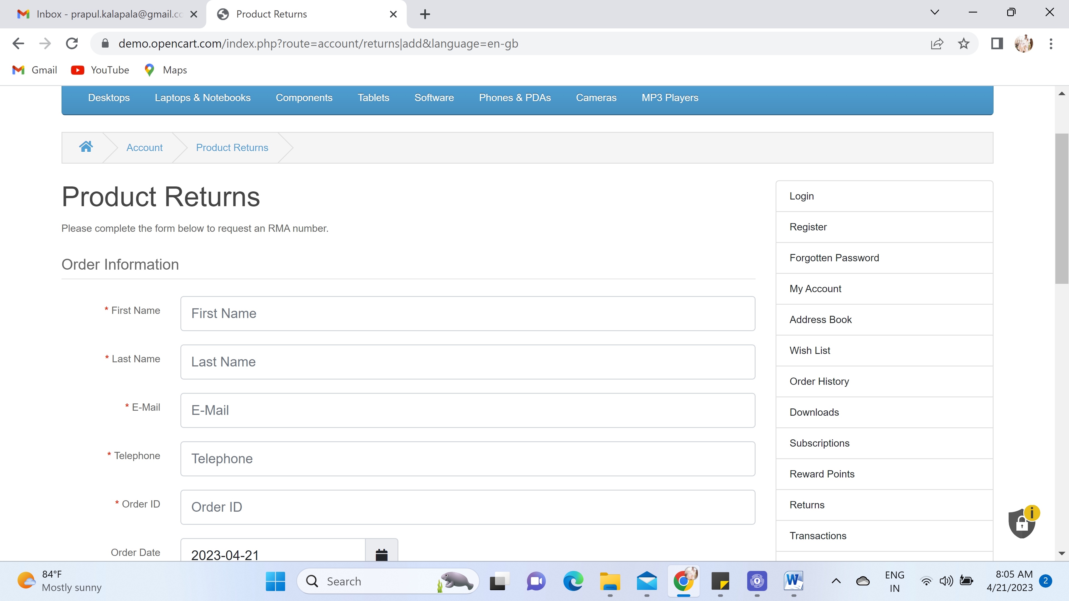

9. Site Map is working and taking directly to the page/product where I clicked on the name.  
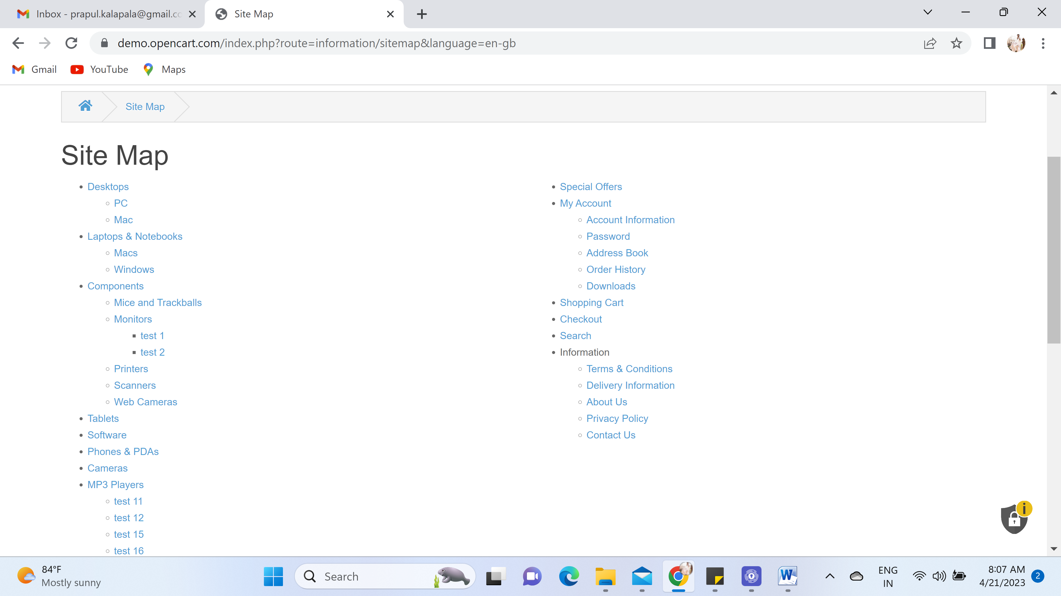

10. Brands section, It is showing the brands available in this website and taking me the page on which brand I clicked  
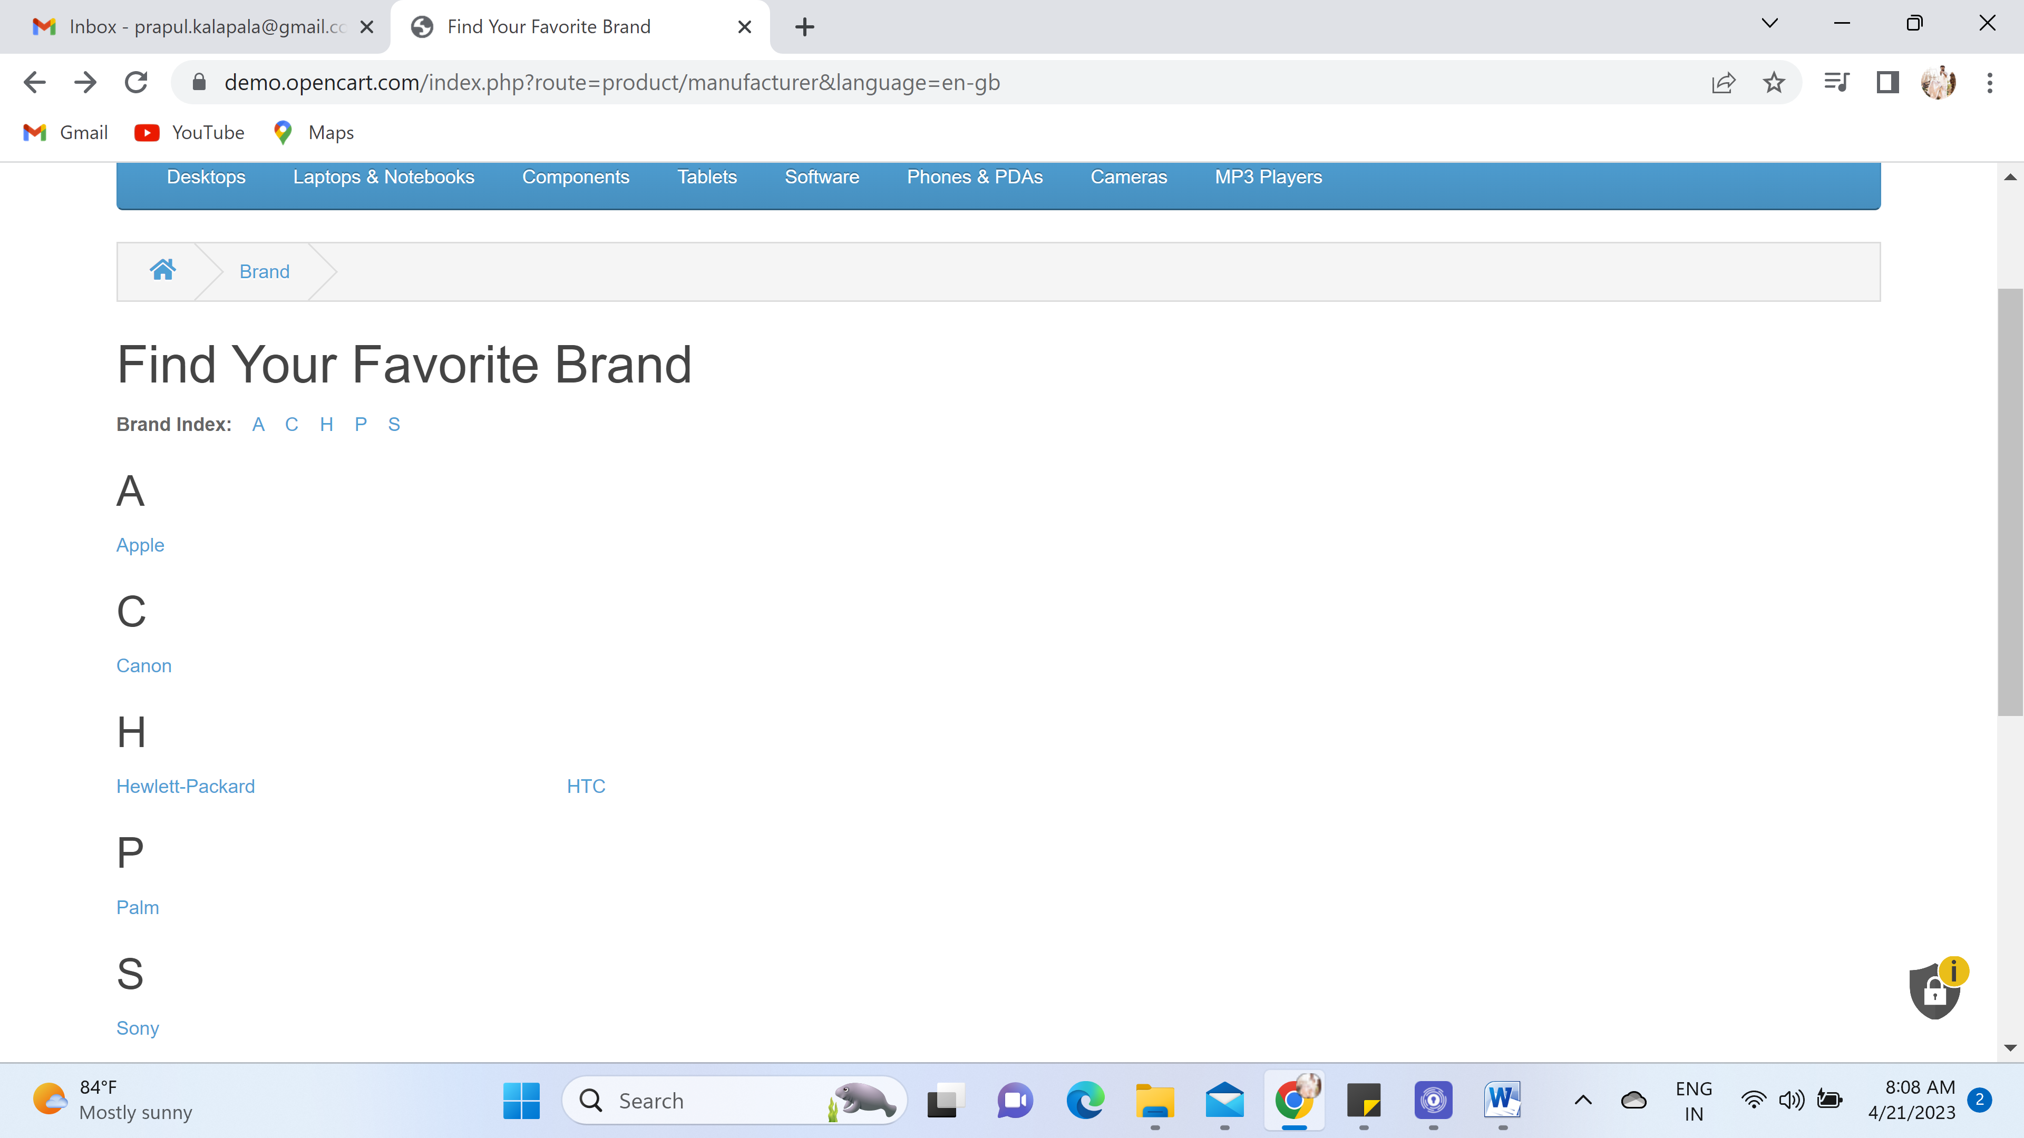  
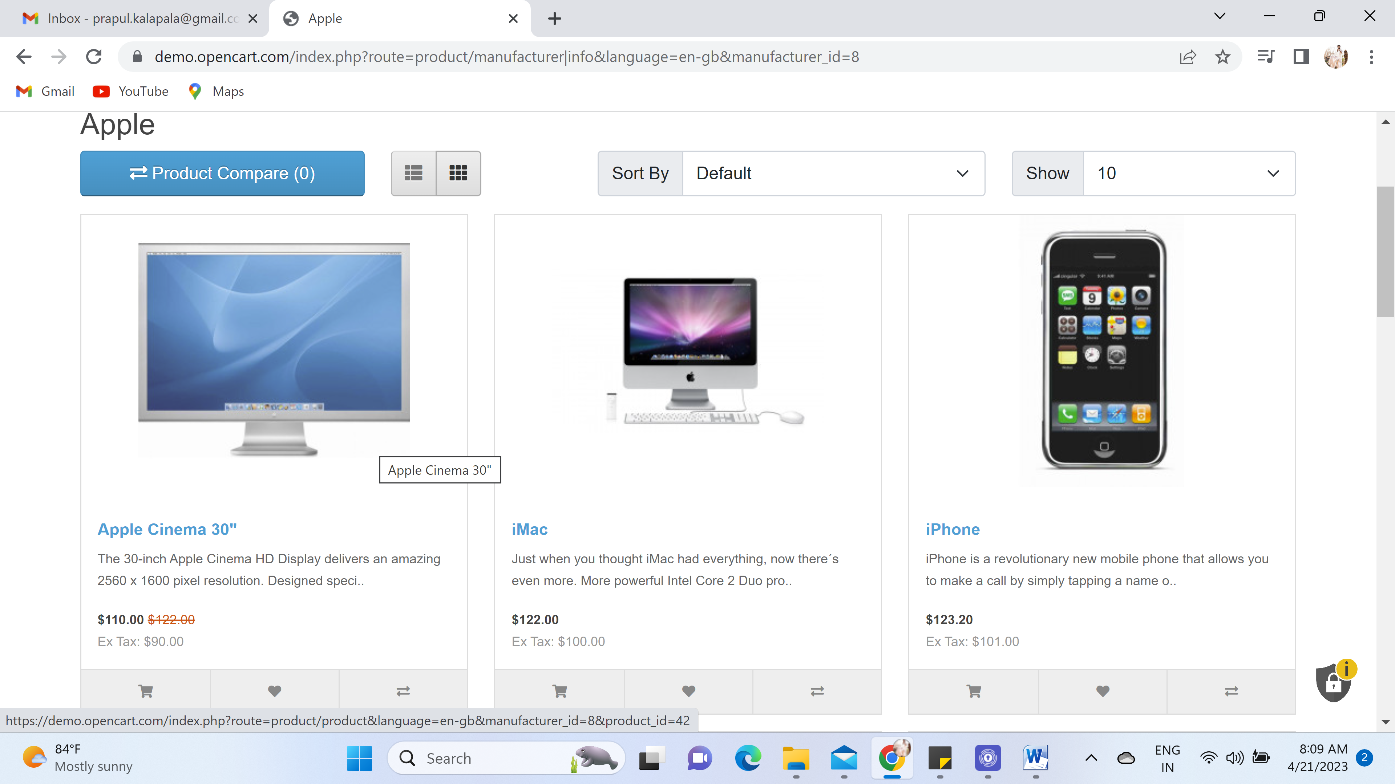

11.Gift Certificates, If I clicked the empty certificate then I can see the error messages below the field.  
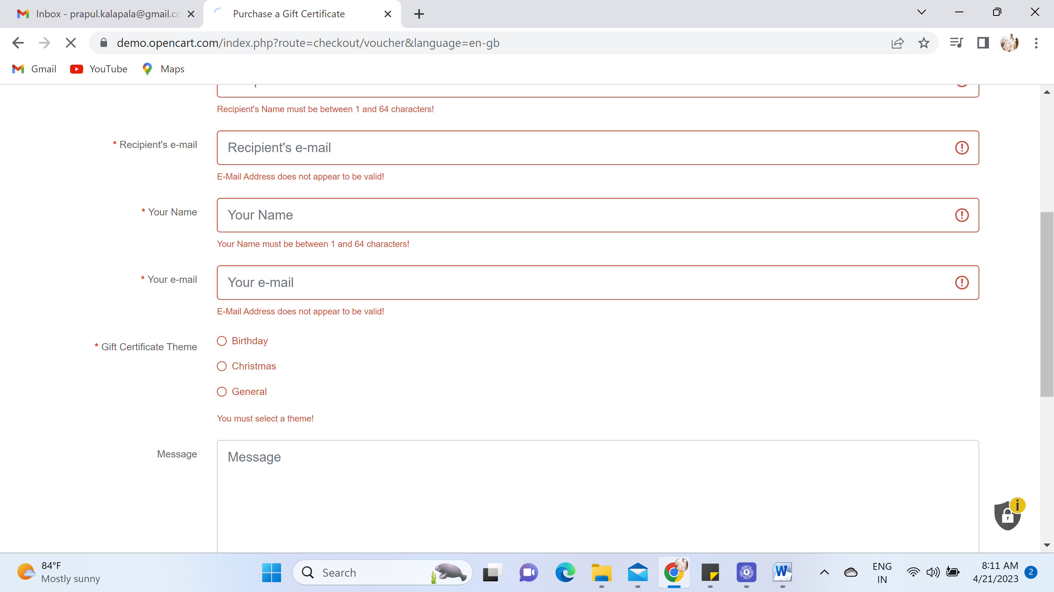

12. If I click on Affiliate link, it is directly taking to the connect/login/register page as shown below!  
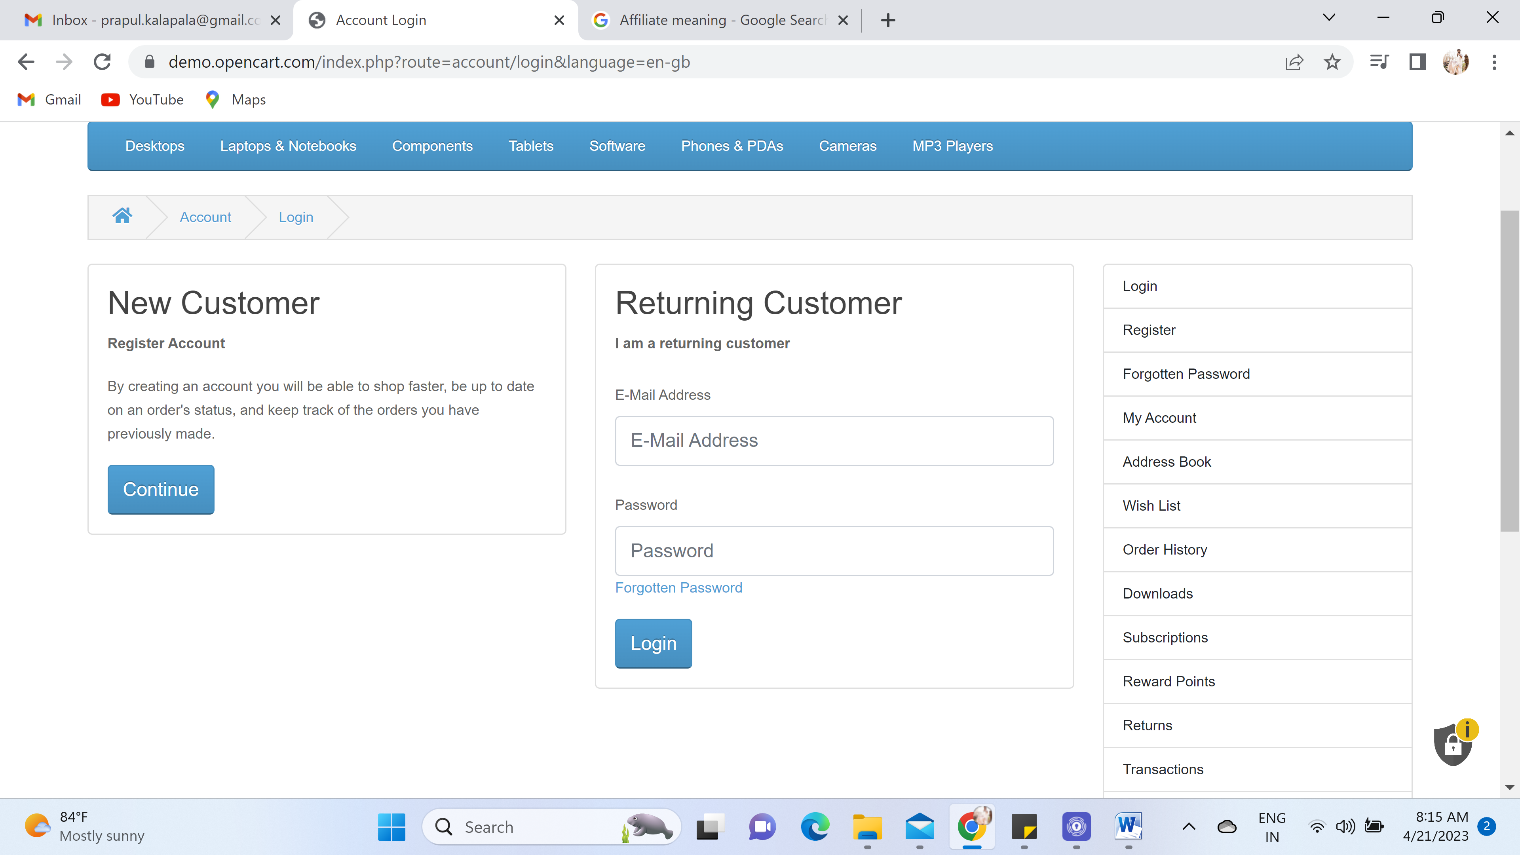

13. In special link, it is re-directing to the special offers/Discounted items page as shown below  
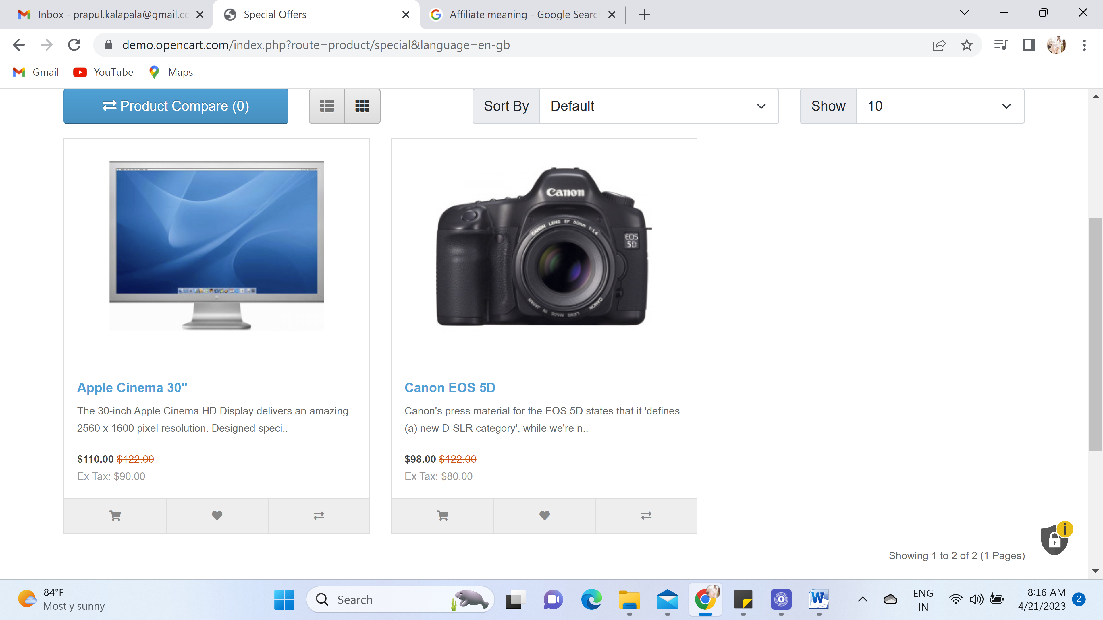

14. In My account section: Account, Order History, WIshlist and Newsletter, if we clicked on this page it is directly taking to the login page. 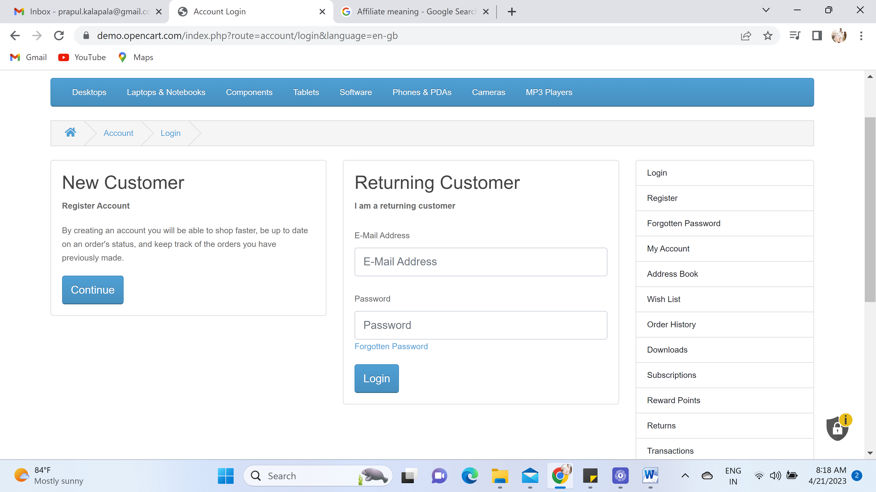

15. Forgotten Password, Given unregistered email adderess and displaying that email is not registered!  
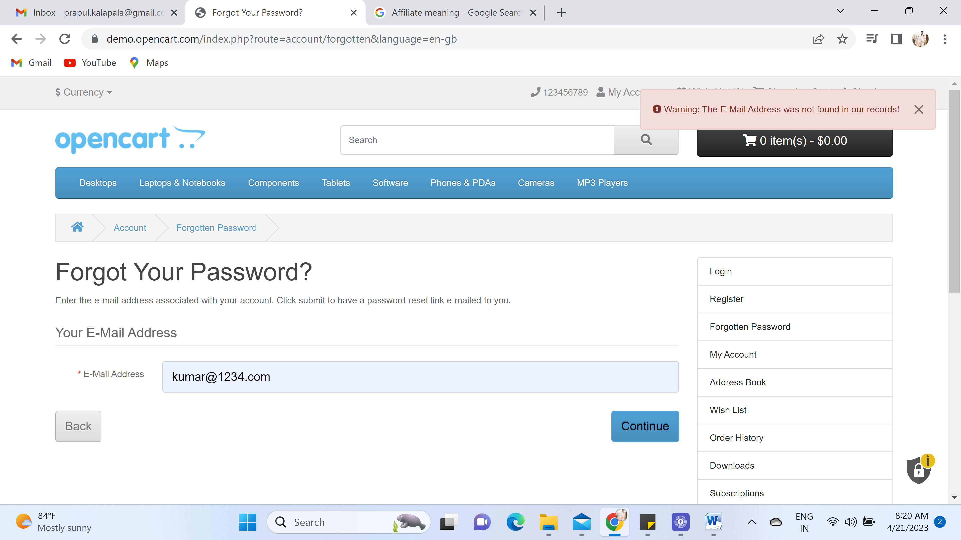  
  
16. While searching the item in the website, Getting 500 server issue as shown below  
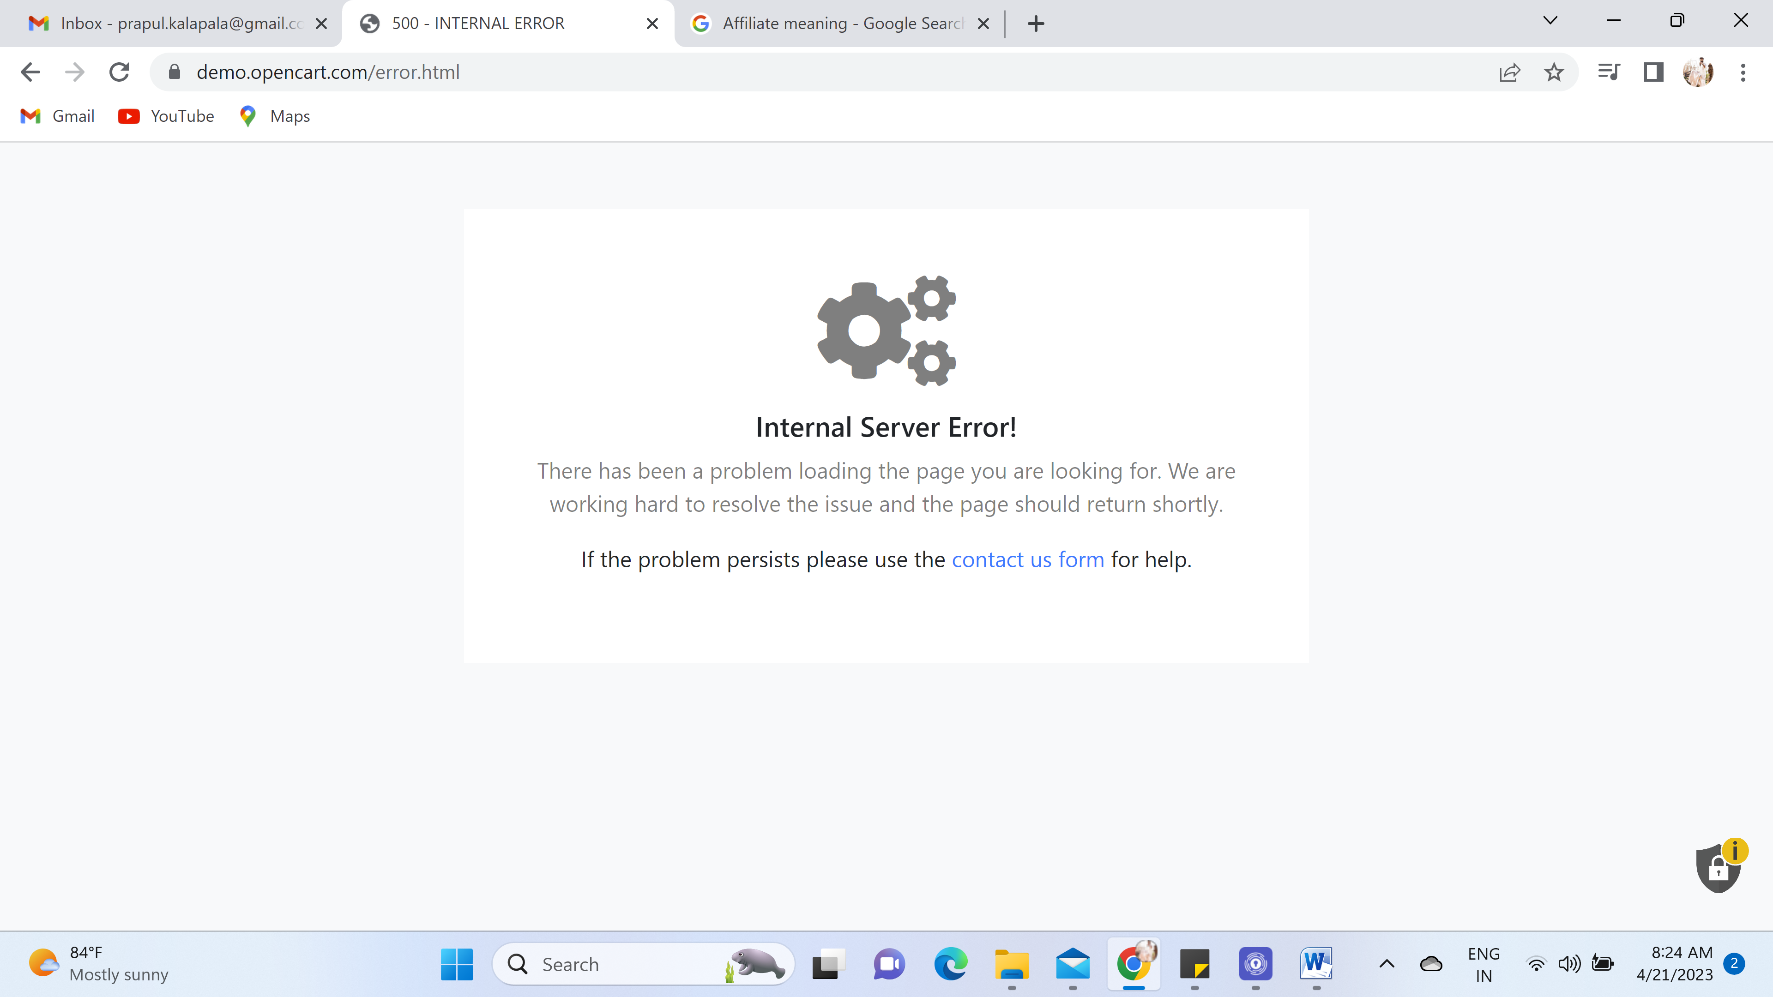

17. Using postman with the method GET, 200OK  
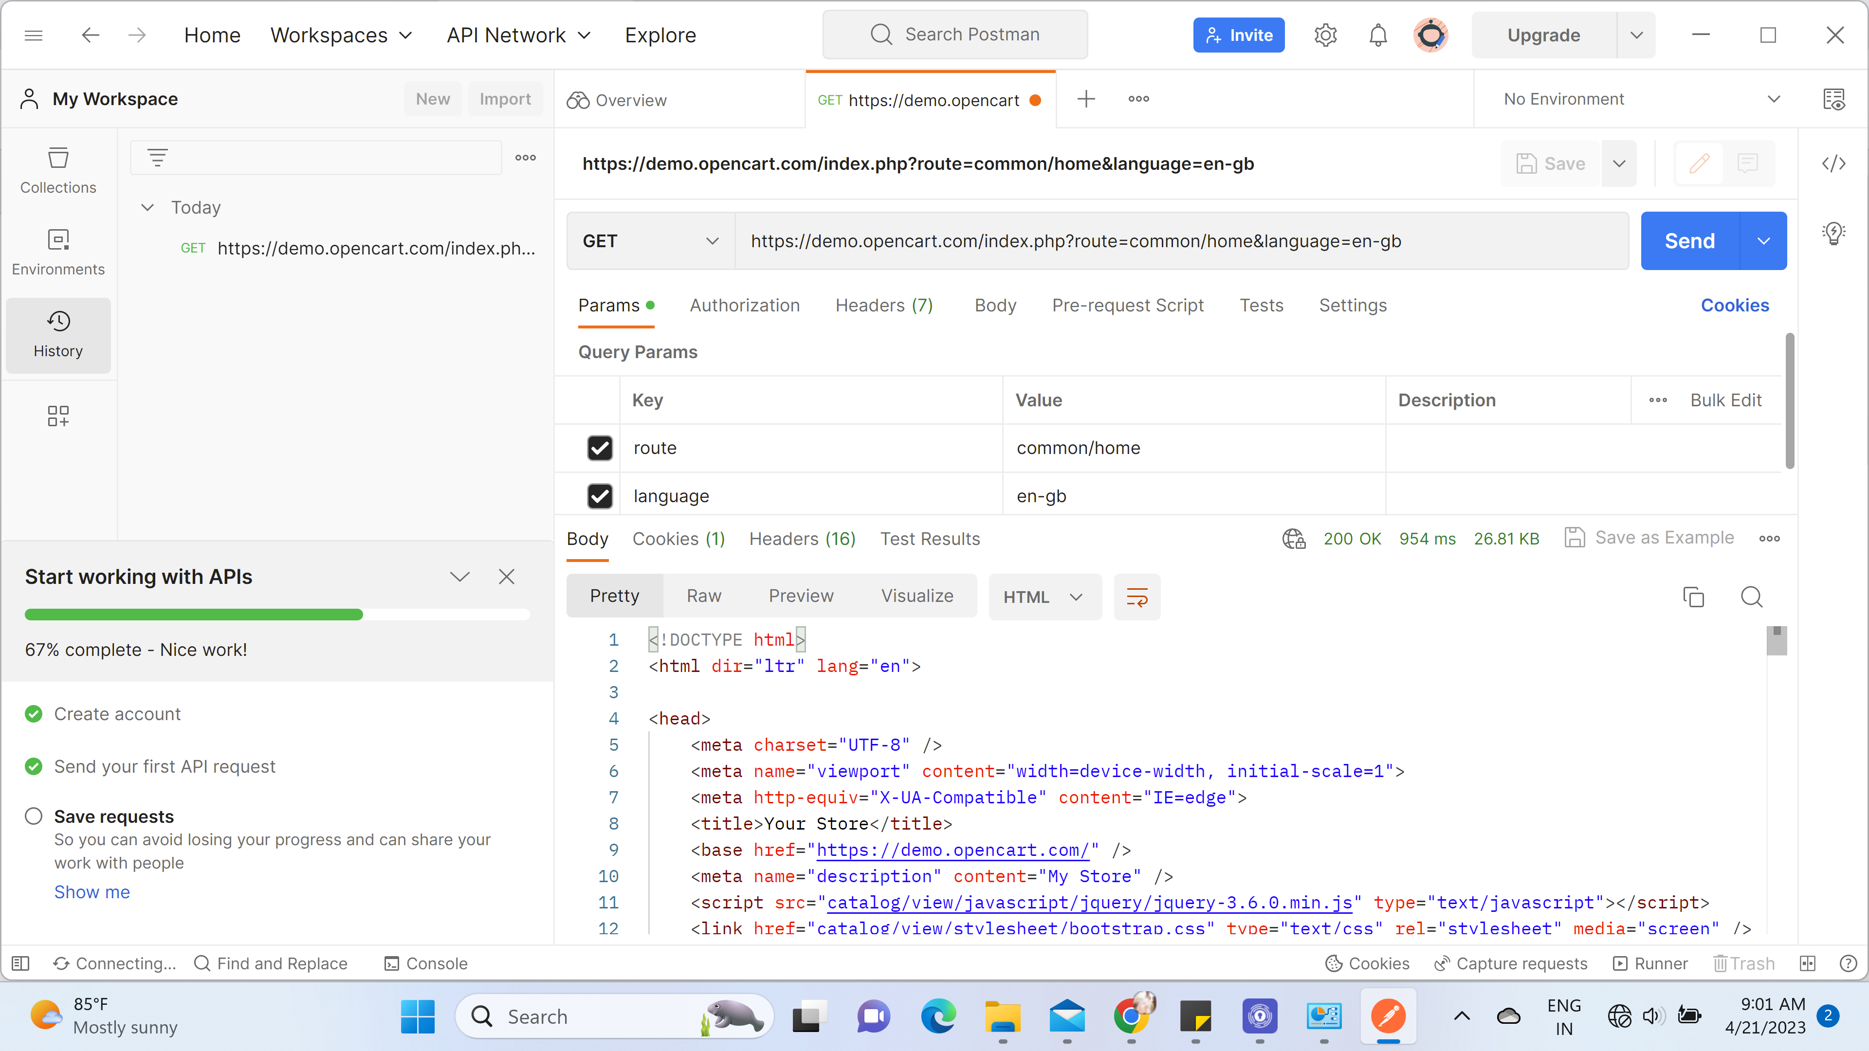  
  
18.